BASKET-MN-Chippewa-Quill Box- birch bark, porcupine quills and black thread
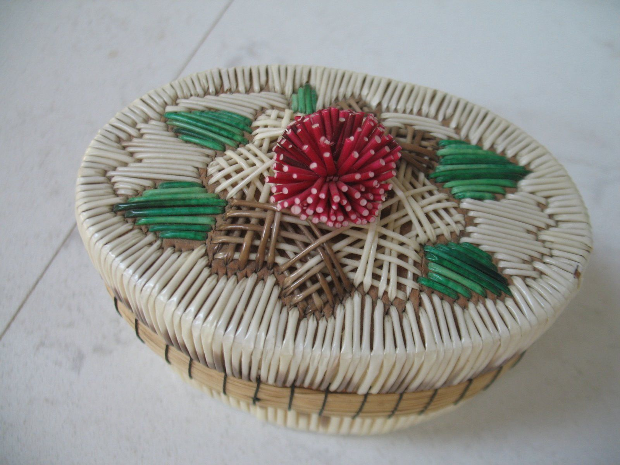
Case No.:
Accession Number:
Formal Label: MN-Chippewa-Quill Box- birch bark, porcupine quills and black thread
Display Description:
Oval quill box with lid made by a Native American Chippewa Indian tribes of the Great Lakes region. The basket is crafted of birch bark, porcupine quills and black thread. The lid of the basket is decorated with a three dimensional interwoven design with tufted flower made with porcupine quills.

LC Classification:
Date or Time Horizon:
Geographical Area:
Map:
GPS Coordinates:
Cultural Affiliation:
Medium:
Dimensions:
Weight:
Provenance:
Condition:
Discussion:
References:

